Circle the foods that you enjoy!

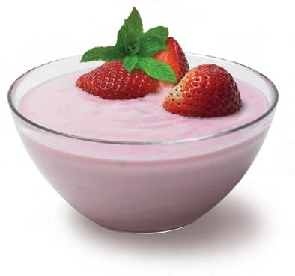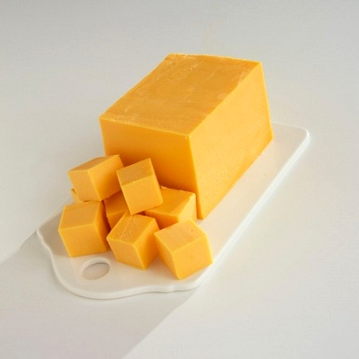
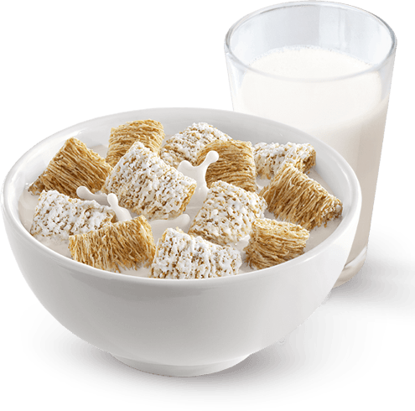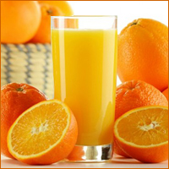
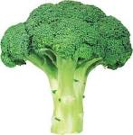

Presentation on Calcium and Vitamin D and how these two nutrients effect your bones

- You may need to increase calcium and vitamin D in their diet.

- You tend to need fewer calories due to your metabolism slowing down.

- You are still required the same amount or increased levels of nutrients. This means that you have unique dietary needs!

- Adequate intake of calcium and vitamin D are best known for the prevention and delay of the progression of osteoporosis.

- You can minimize your risk of falls if you are consuming recommended amounts of calcium and vitamin D, maintaining a healthy body weight, and are physically active.

- You may require calcium and vitamin D supplements.

Foods high in calcium- Milk, Yogurt, Cheese, Broccoli and Cereals

Foods high in vitamin D- Orange Juice, Eggs, Cereals and Tuna. Sunlight is a great source of vitamin D during the sunny seasons!

- Position of the American of Nutrition and Dietetics: Food and Nutrition for Older Adults: Promoting Health and Wellness. J Acad Nutr Diet . 2012; 112(8): 1260.
- Tufts University nutrition scientists unveil MyPlate for Older Adults. Tufts Now website. http://now.tufts.edu/news-release/tufts-university-nutrition-scientists-unveil-. Accessed Janurary 3, 2015.

