Microwave Friendly Recipes

Do you mostly use your microwave oven to heat up leftovers? Well it’s time to put your microwave to work because it's good for so much more! They’re called ovens for a reason, and they can create meals equal to anything from a standard oven.
Skeptical? Below you’ll find a list of absolutely delicious meals that will quickly make you rethink the term “microwave meal.” Prepare one for yourself! You won’t believe your taste buds.

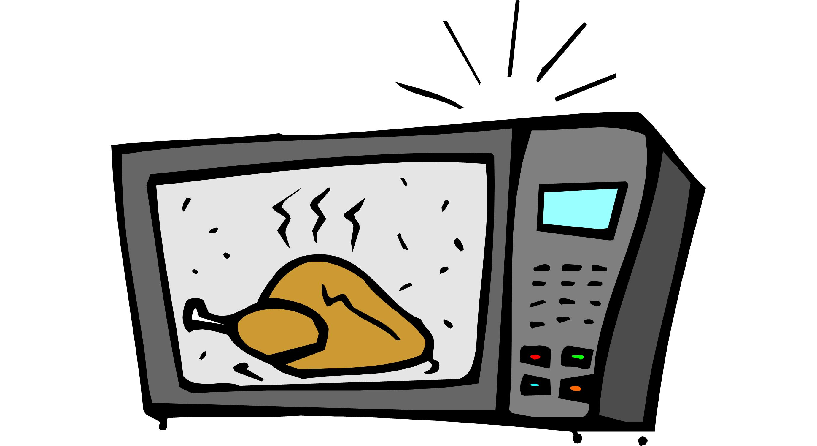

Rice-Stuffed Peppers (5 servings)

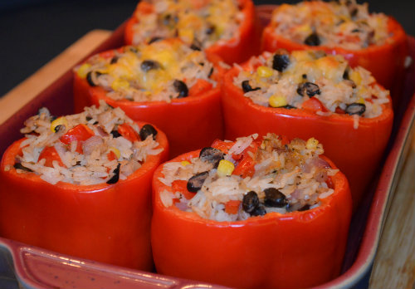

1 cup brown rice
4 cups water
1 tsp dried basil (optional)
1 tsp garlic powder
½ tsp salt
5 medium bell peppers
3 medium tomatoes, chopped
1 (15 ounce) can black beans, drained

Combine the brown rice, water, dried basil, garlic powder and salt in a microwave safe bowl and microwave for 15 minutes, or until the water is absorbed.

Slice the tops off of the peppers, and remove the seeds and cores. Set aside. When the rice is done, stir in the tomatoes and black beans. Spoon into the peppers until filled. Place the peppers into a microwave safe dish and cook in the microwave for 10 minutes, or until peppers are tender. Turn peppers every 2 to 3 minutes to ensure even cooking.

Add cheese or salsa on top of the dish for an extra kick of flavor!

Baked Potato (1 serving)

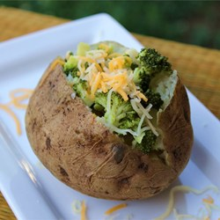

1 large russet potato
1 tablespoon butter or margarine
3 tablespoons shredded cheddar cheese
salt and pepper to taste
3 teaspoons sour cream

Scrub the potato, and prick several time with the tines of a fork. Place on a plate.
Cook on full power in the microwave for 5 minutes. Turn over, and continue to cook for 5 more minutes. When the potato is soft, remove from the microwave, and cut in half lengthwise. Season with salt and pepper, and mash up the inside a little using a fork. Top the open sides with butter and 2 tablespoons of cheese. Return to the microwave, and cook for about 1 minute to melt the cheese.
Top with remaining cheese and sour cream, and serve.

Quesadillas (1 serving)

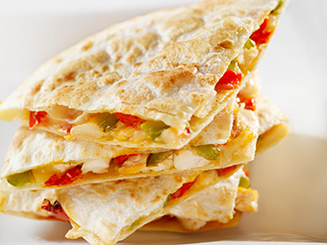

2 corn OR flour tortillas

2 cups Monterey Jack OR cheddar cheese, shredded

Filling ideas:

Onions

Peppers

Broccoli

Refried beans

Black beans

Cooked shredded pork

Cooked shredded beef

Cooked chicken breast

Place one tortilla on a microwave-safe plate. Sprinkle 1/2 cup shredded cheese on half of the tortilla. Add vegetables, cooked meat or beans on top of cheese.

Heat in microwave oven for 15 to 20 seconds. Remove from microwave and fold tortilla in half. Cut in wedges to serve. Repeat with remaining tortillas.

Potato Chips (4 servings)

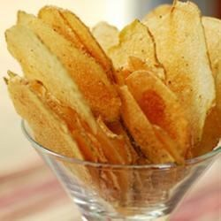

1 tablespoon vegetable oil
1 potato, sliced paper thin (peel optional)
½ teaspoon salt, or to taste

Pour the vegetable oil into a plastic bag (a produce bag works well). Add the potato slices, and shake to coat.
Coat a large dinner plate lightly with oil or cooking spray. Arrange potato slices in a single layer on the dish.
Cook in the microwave for 3 to 5 minutes, or until lightly browned (if not browned, they will not become crisp). Times will vary depending on the power of your microwave. Remove chips from plate, and toss with salt (or other seasonings). Let cool. Repeat process with the remaining potato slices. You will not need to keep oiling the plate.

Sweet Potato Chips (2 servings)

1 sweet potato, thinly sliced
2 teaspoons olive oil, or as needed
Salt to taste

Combine sweet potato slices and and olive oil in a large bowl; toss to coat. Arrange sweet potato slices in a single layer on a large microwave-safe plate; season with salt.
Cook in microwave until chips are dry, crisp, and slightly browned, about 5 minutes. Cool chips on plate before transferring to a bowl. Repeat with remaining sweet potato slices.

Microwave corn on the cob (1 serving)

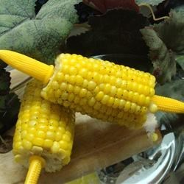

1 ear corn, husked and cleaned

Wet a paper towel, and wring out. Wrap the ear of corn in the moist towel, and place on a dinner plate. Cook in the microwave for 5 minutes. Carefully remove paper towel, and enjoy!

Cauliflower with Dijon Sauce (4 servings)

1 head cauliflower, separated into florets
½ cup mayonnaise
¼ cup Dijon mustard
1 cup shredded sharp Cheddar cheese

Place cauliflower florets in a large glass bowl or casserole dish, and cover with plastic wrap. Poke a few holes in the plastic with a knife. Cook in the microwave for 5 to 7 minutes, or until tender.
In a cup or small bowl, stir together the mayonnaise, and Dijon mustard. Spread over the top of the cauliflower. Sprinkle shredded cheese over the top. Return to the microwave, and cook just until cheese has melted, about 2 minutes.

Easy Spinach Soufflé (4 to 6 servings)

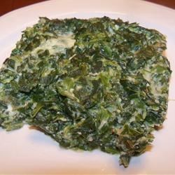

1 egg
1/3 cup 1% milk
1/3 cup grated Parmesan cheese
1 teaspoon crushed garlic
salt and pepper to taste
2 (10 ounce packages frozen chopped spinach, thawed and drained

In a medium bowl whisk together egg, milk, cheese, garlic, salt and pepper. Fold in spinach. Place in a small casserole dish.
If you are in a hurry, use a microwave safe casserole dish, cover with plastic wrap, and cook on high for 3 minutes. Release the steam, recover, and cook on high for another 3 minutes. Enjoy!

Omelet in a Mug (1 serving)

2 large eggs
2 tablespoons shredded Cheddar Cheese
3 tablepoons diced green bell pepper and onion
salt and ground black pepper to taste
cooking spray

Combine eggs, Cheddar cheese, bell pepper, onion, salt, and ground pepper in a microwave-safe mug coated with non-stick spray.
Microwave on high for 1 minute; stir. Return to microwave and cook until eggs are completely set, 1 to 1 1/2 minutes longer.

Inside-Out Pizza (1 serving)

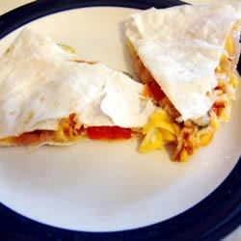

2 6-inch flour tortillas
¼ cup grated Cheddar cheese
¼ cup shredded Mozzarella cheese
1 tablespoon chopped tomato
1 tablespoon sliced black olives
1 tablespoon chopped green bell pepper

Place one tortilla on a sheet of waxed paper sized to fit in your microwave. Spoon 2 tablespoons each of Cheddar and Mozzarella cheeses over the tortilla. Top with 1 tablespoon each tomatoes, black olives, and green peppers. Sprinkle with remaining Cheddar and Mozzarella cheeses, and place second tortilla on top. Place on a microwave-safe plate, and cover with a sheet of waxed paper.
Cook on High in microwave until the cheese melts, about 1 1/2 minutes. Allow to cool 2 minutes before cutting into wedges.

Cinnamon Sugar Tortilla Delight (1 serving)

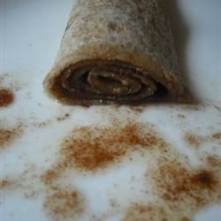

1 (10 inch) Whole Wheat tortilla
2 teaspoons butter-flavored spread
1 ½ tablespoon cinnamon sugar

Spread tortilla with butter-flavored spread; sprinkle with cinnamon sugar. Roll into a tube shape, then place on a microwave safe plate. Microwave on High for 30 seconds to warm.

