Emily Kaley
3/31/15
Research Paper
Winston Salem Forsyth County

Healthy School Lunch Policies Cause Controversy as Waste Collects

Between the 2010-11 and 2012-13 school years, the number of students enrolled in the National School Lunch Program (NSLP) fell by about 1.2 million children (1). Policy changes intended to make school meals healthier are causing controversies and unintentional concerns. The U.S. Department of Agriculture (USDA) oversees the NSLP and in 2012, first lady Michelle Obama helped create new USDA guidelines that require lunches to contain more fruits, vegetables, and whole grains. The changes limit salt, sugar, fat, and calories in school meals as part of her “Let's Move!” campaign to fight childhood obesity. Schools are required to comply if they want to receive federal funding through the NSLP. Students are expressing their dissatisfaction for the healthier meals and consequently wasting untouched nutritious food items every day. Researchers provoked by the issue are exploring exactly where the students are missing the health path and what exactly needs to happen to improve student school meal participation and increase student consumption of the healthy foods being offered to them. Healthy school lunch policies should stay in place regardless of declining participation and waste collection as these issues will take a turn for the better with increased health education in the classrooms and at home.

Previous school meal standards were developed 15 years ago and didn't meet nutritional guidelines recently established by health and nutrition experts. The Institute of Medicine thoroughly looked into this and in December 2010 the Healthy, Hunger-Free Kids Act was passed. This Act was legislated to provide nutritious meals to all children across America. Although science has paved the way, that doesn't mean it's easy to serve the students the foods they not only need, but they actually like and will eat. As childhood obesity is at utmost concern, it was necessary and imperative that these new regulations be put into place as soon as possible. A study by Stuempler et al. (2) found that nutrition programs can increase fruit and vegetable intake and that even moderate increases in fruit and vegetable intake can be an initial step for the prevention of chronic disease. If the students are regularly exposed to fruits and vegetables and participate in nutrition programs on a daily/weekly bases there will be a slow but successful increase in consumption of these healthier items. Change is not easy, especially when changing individuals eating habits but in the long run the changes will be critically beneficial.

Some of the new regulations were too much, too fast, and are turning students away from healthy school meals with some students are even complaining of going hungry. Some hungry students are arguing that they aren't being served the calories they need and are unfortunately consuming junk food to fill up. It’s possibly that teachers didn’t have enough time or resources to properly prepare for the change. A study by Mita et al. (3) used the Information-Motivation-Behavioral Skills model and had researchers qualitatively assess preschool teachers’ received motivation, facilitators and barriers related to getting preschool children to eat fruits and vegetables. This study found that in the Information construct, teachers perceived that they lacked facts about fruits and vegetables. In Motivation, teachers believed themselves to be parents at school and discussed both intrapersonal and interpersonal factors in the students that would affect a teacher's ability to successfully increase student’s fruit and vegetable consumption. Finally, in the Behavioral Skills construct, teachers discussed the strategies and skills they used to encourage students to eat fruits and vegetables, as well as their self-efficacy related to successfully increasing student’s fruit and vegetable consumption. Teachers are aware of the benefits of eating fruits and vegetables and understand that they are looked at as a parent figure but they also realize that they lack the facts about fruits and vegetables, which negatively reflects on the student. This transition into the new regulations happened too fast and we should have taken a step back to accurately prepare all parties involved.

With healthier options on the menu, students must select either a fruit or a vegetable, but that doesn’t mean they have to eat them. A study by Soldavini et al.(4) with the objective to determine whether students perceive food with nutrition claims as healthier and tasting differently than those without claims found that children selected food products they perceived or were told were healthier as tasting better. This finding implies that they might choose such products on the basis of perceived health. The time should be taken and resources should be utilized to show case the nutrition claims on healthier items. This may show a positive effect on the students and entice them to choose and consume healthier options.

The time spent in the kitchen preparing meals is valued to each task which leaves little room for extra duties like placing information for nutrition claims on healthier options. If there are more duties assigned there may be a need to employ more staff. This will cost the school more money and in turn cost the taxpayers. The students can learn about the benefits of fruits and vegetables in the classroom and at home, not in the cafeteria.

This is a perfect time for the government, schools, parents, and communities to join together to help students find the healthy path and get excited about living a healthier lifestyle. By utilizing successful nutrition programs in schools, there will be an increase in fruit and vegetable consumption. These nutrition programs need to be not only implemented in a fun and enticing way but the lessons learned need to be integrated in the classroom and taken home to share with family members. Although the cafeteria can be a classroom through the introduction of healthier options, teachers and parents need to become a team and step up to the plate to teach healthy lifestyle eating habits. Students want to be healthy and make better choices when told a certain food is healthy but they need guidance and may benefit from observing nutrition claims throughout the lunch line. Increased health education in the classrooms and at home will help to increase meal participation and decrease waste collection as these healthy school lunch policies stay in place.

Citations:

- School Lunch: Implementing Nutrition Changes Was Challenging and Clarification of Oversight Requirements Is Needed. GAO-14-104. Washington, D.C.: January, 2014.

- Barbara J. Struempler, Sondra M. Parmer, Lisa M. Mastropietro, Dilbur Arsiwalla, Robert R. Bubb. Changes in Fruit and Vegetable Consumption of Third-Grade Students in Body Quest: Food of the Warrior, a 17-Class Childhood Obesity Prevention Program. J Nutr Educ Behav. 2014; 46: 286-292

- Satoko C. Mita, Eileena Li, L. Suzanne Goodell. A Qualitative Investigation of Teachers' Information, Motivation, and Behavioral Skills for Increasing Fruit and Vegetable Consumption in Preschoolers. J Nutr Educ Behav. 2013;45: 793-799

- Jessica Soldavini, Patricia Crawford, Lorrene D. Ritchie. Nutrition Claims Influence Health Perceptions and Taste Preferences in Fourth- and Fifth-Grade Children. J Nutr Educ Behav. 2012; 44: 624-627

Examples of Actual Plate Waste: Photos of 5 middle school lunch trays just before being thrown out

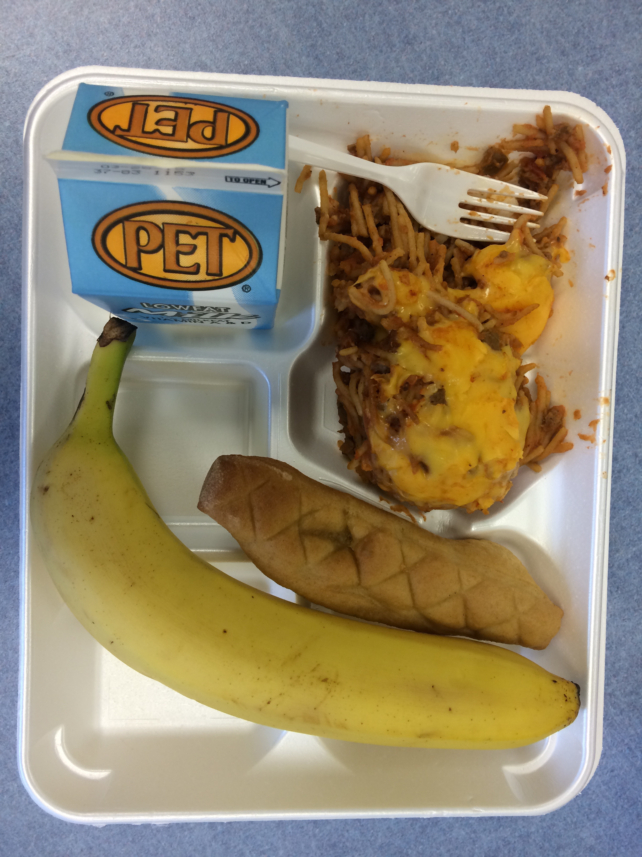 Untouched Banana, WW Bread stick and Low Fat Milk

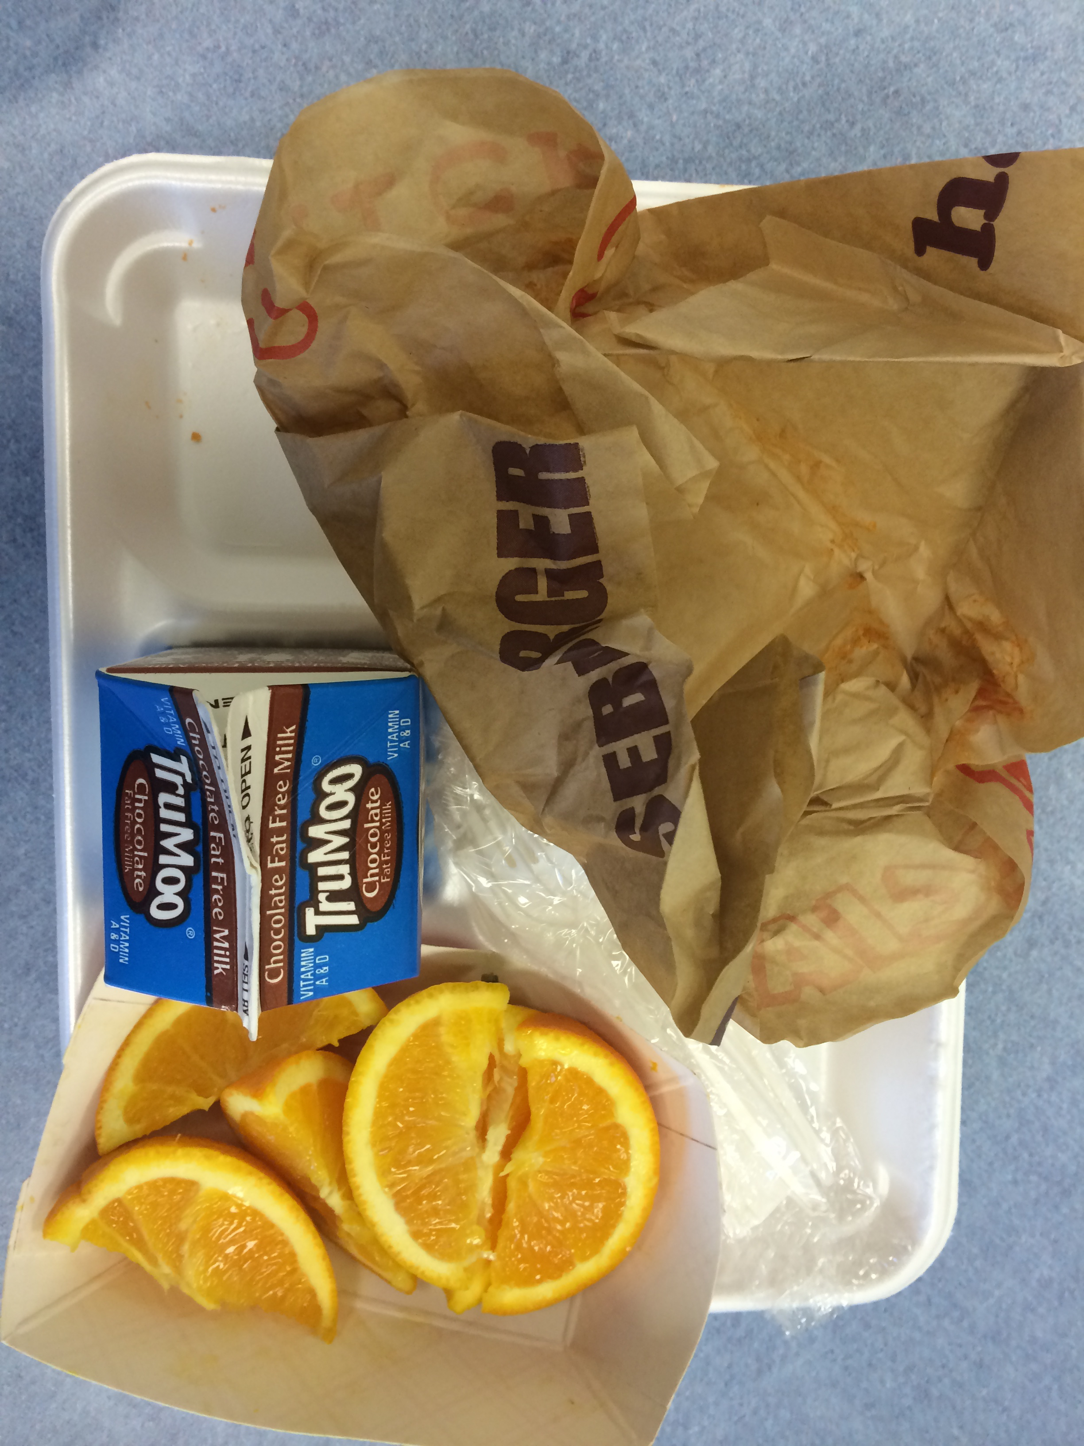 Untouched whole wedged orange

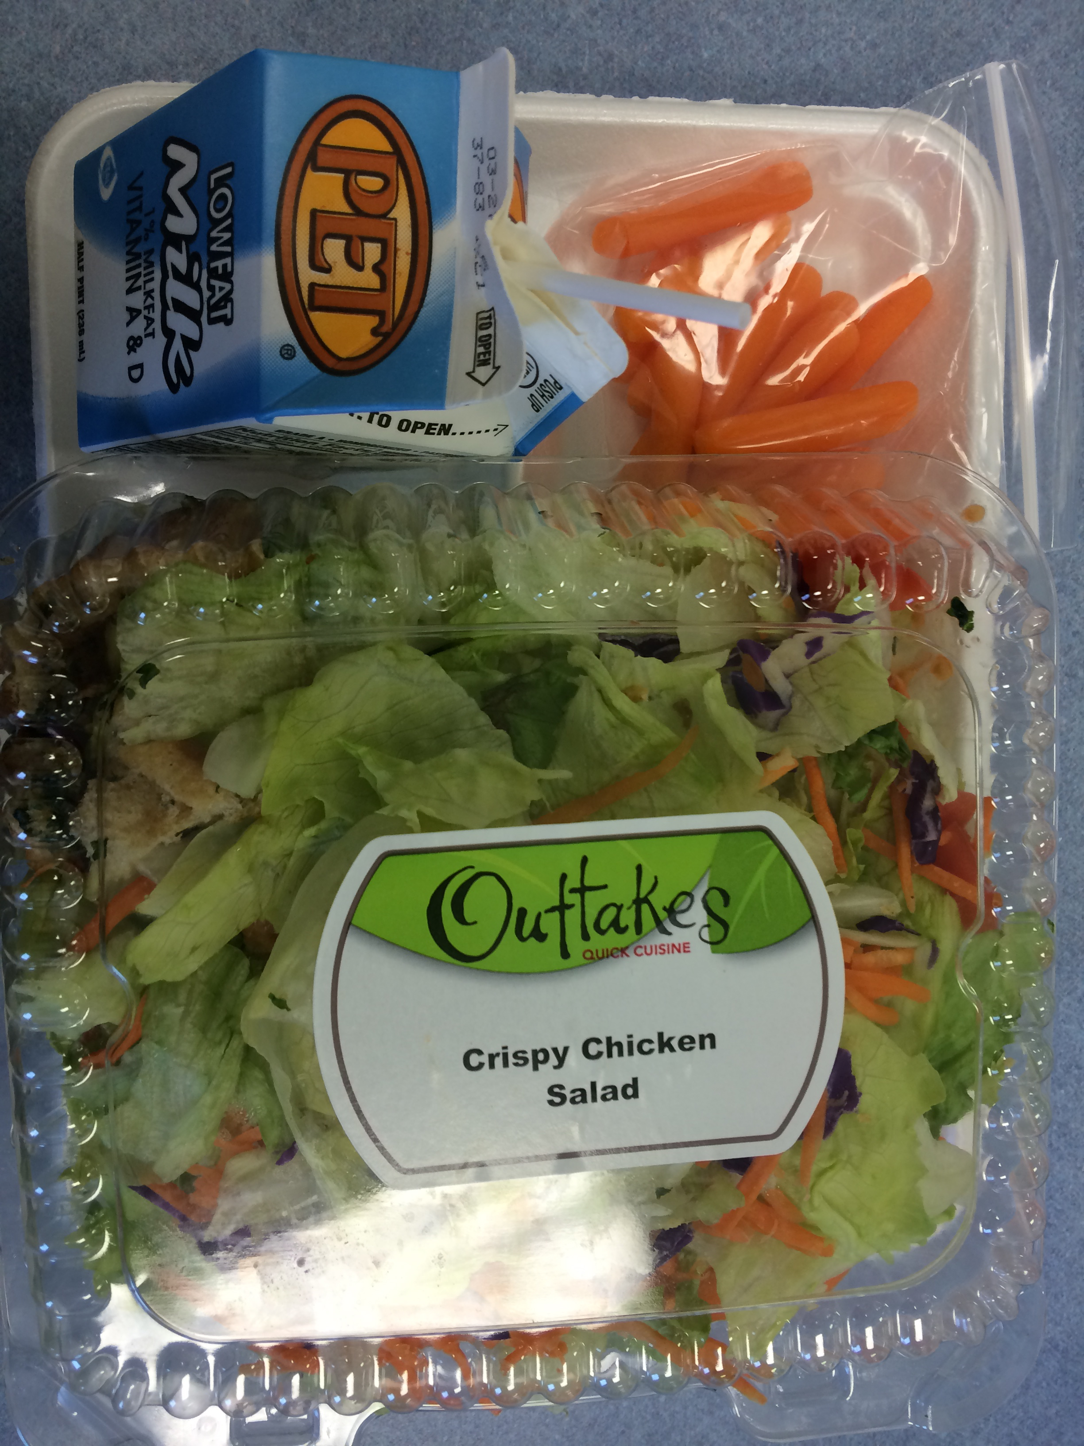 Untouched Crispy Chicken Salad and carrot sticks

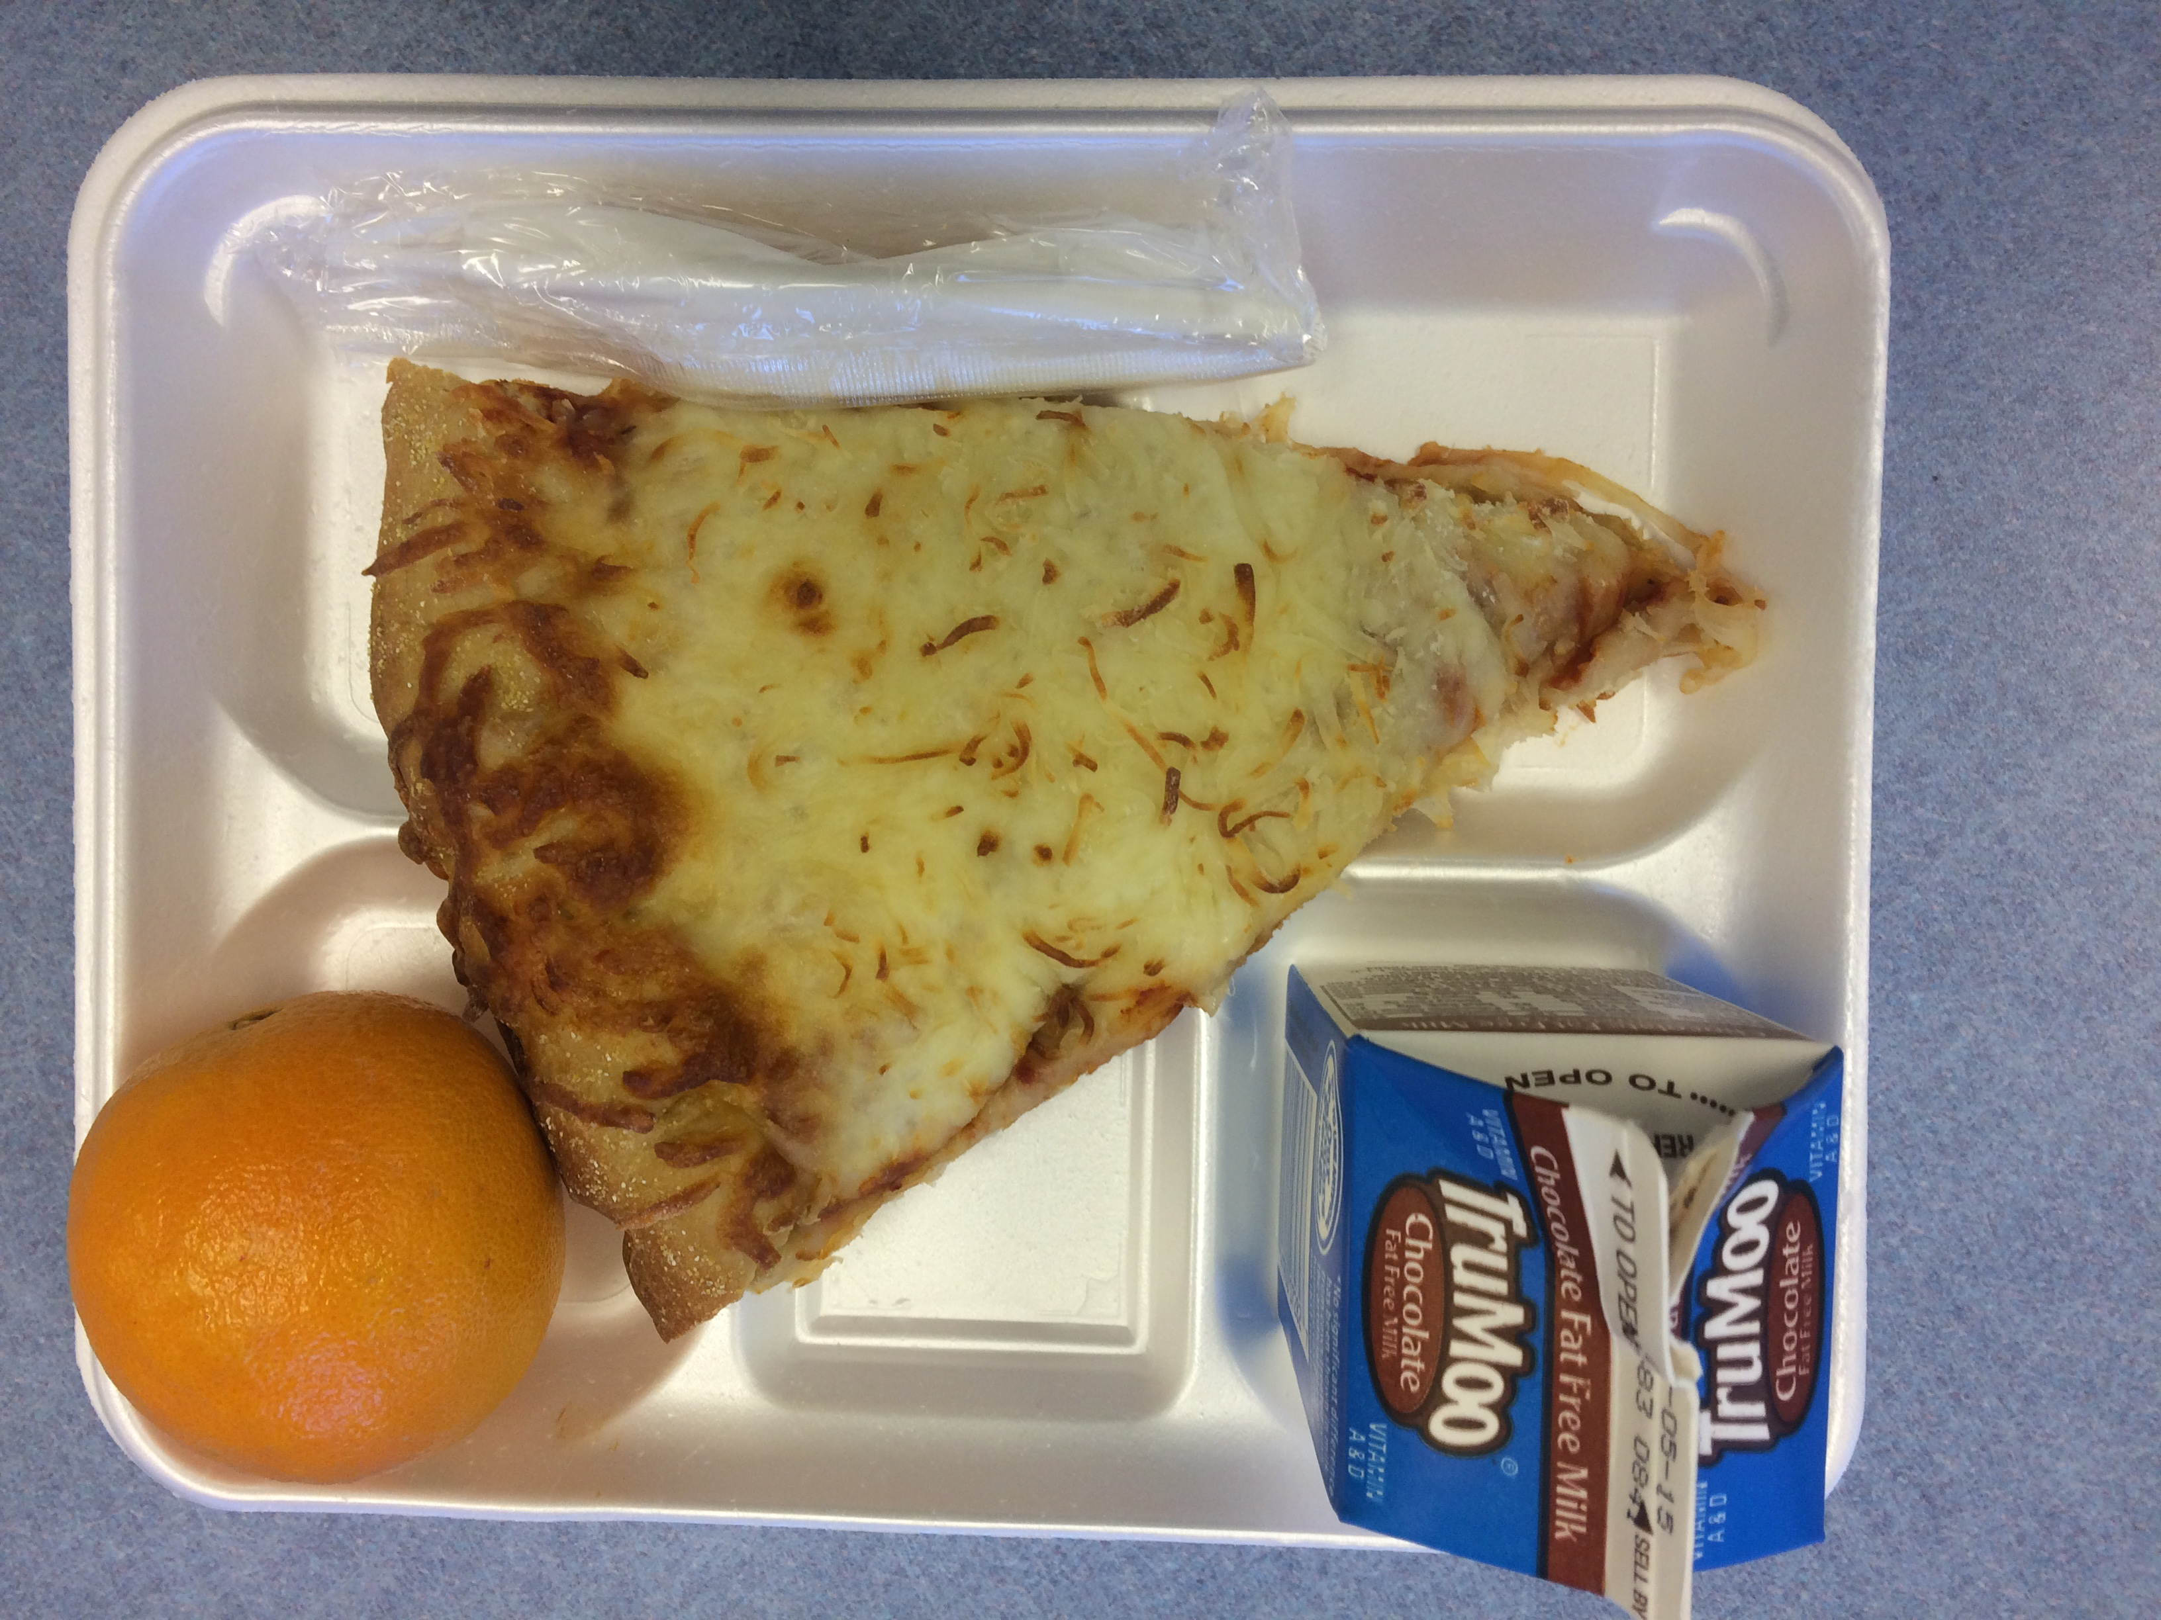 Untouched cheese pizza and whole orange

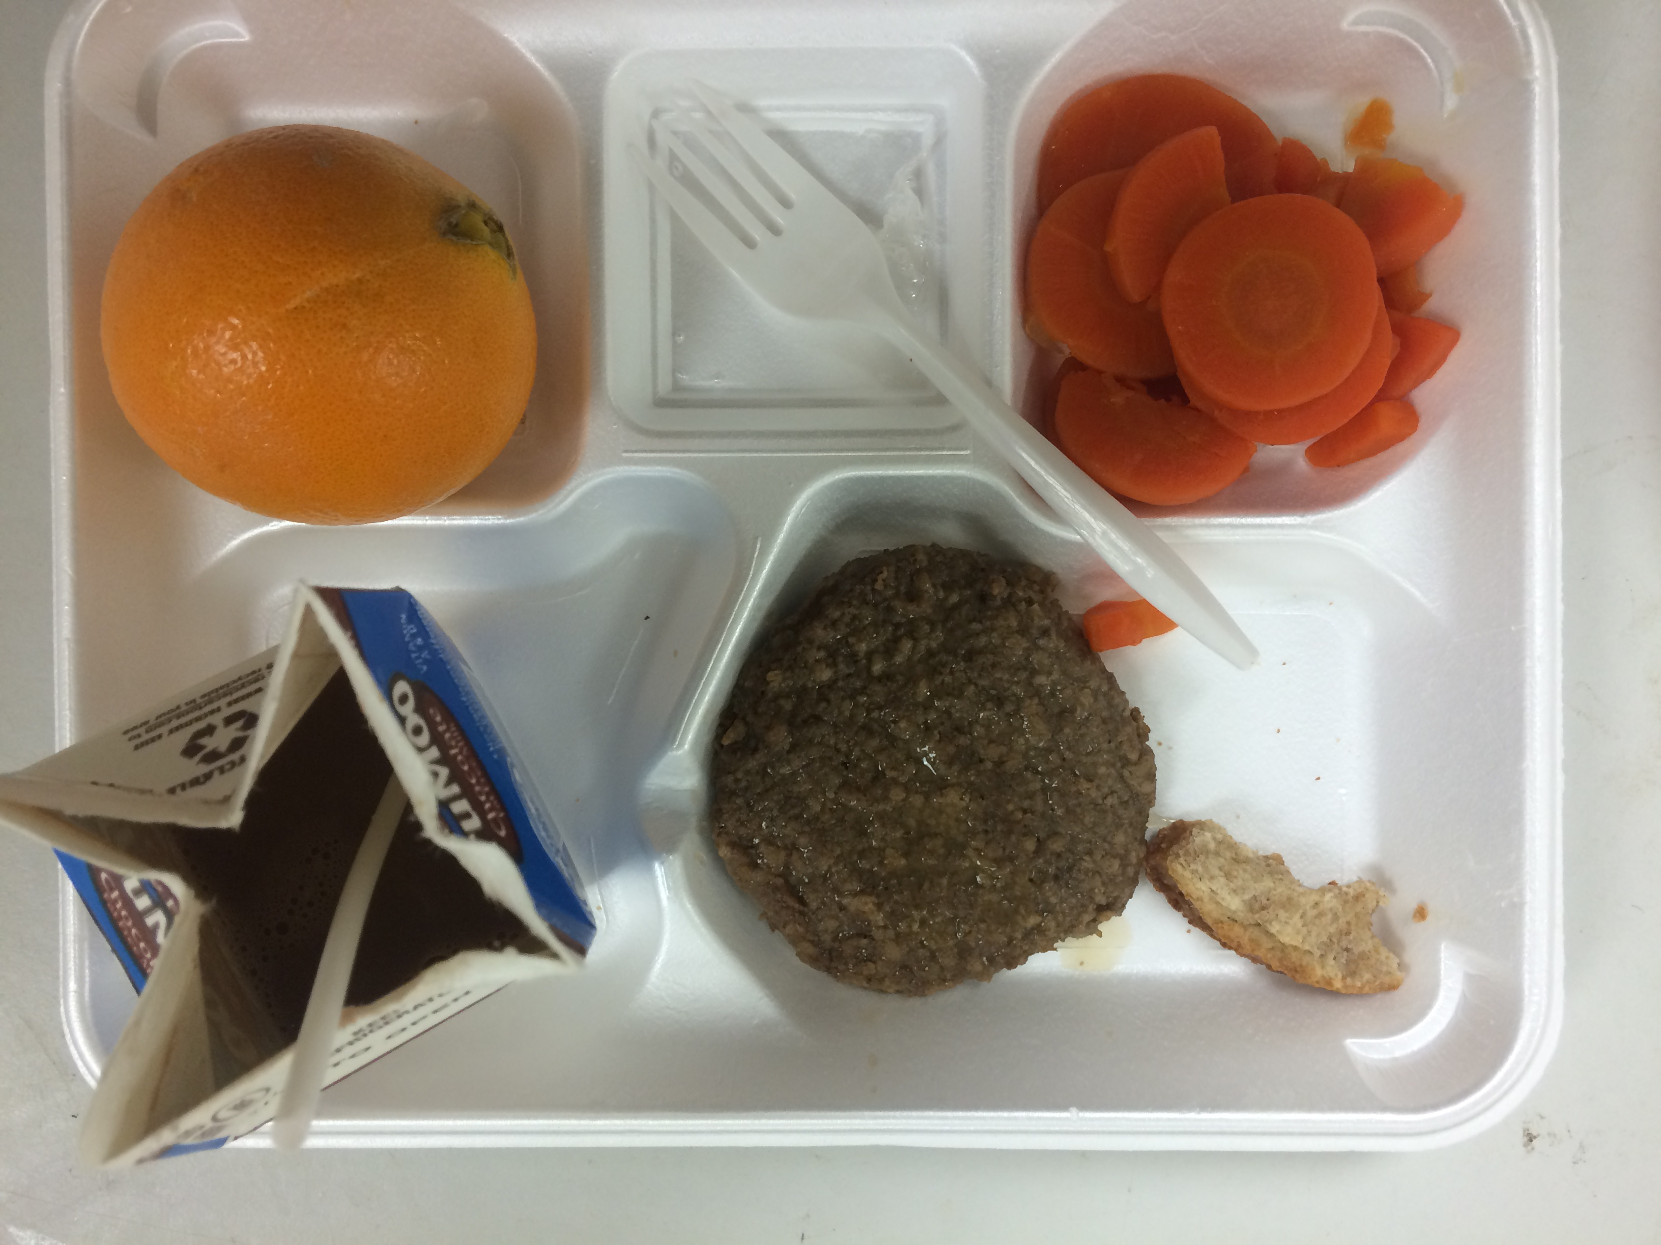 Untouched whole orange, beef patty and ¾ carrots remaining

