December 3, 2014
Superfood Strawberry Chia Smoothie Issue # 526

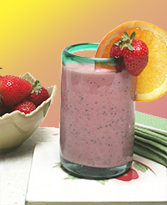

Smoothies are a great healthy way to start your day! This delicious breakfast blend of fruit, milk and seeds is full of protein, calcium and fiber. Strawberries contain ellagic acid, which may
act as an antioxidant and decrease unwanted inflammation. Chia seeds are loaded with fiber, rich in omega-3s and a good protein source. A sweet quick fit with the same amount of fiber as a bowl
of oatmeal for less than 250 calories.

- Ingredients
- 3/4 cup skim milk
- 4 tsp. chia seeds
- 1 cup fresh strawberries
- 1 Tbsp. strawberry fruit spread, or to taste
- 2 tsp. orange zest
- 1/2 tsp. chopped fresh ginger
- 1/2 tsp. vanilla extract

Directions
In blender, add milk and chia seeds and let sit while measuring remaining ingredients.
Add strawberries, preserves, orange zest, ginger and vanilla to blender. Mix on high speed until smoothie is blended and smooth (about 1 minute). Pour smoothie into tall glass and enjoy!

Makes 1 serving.

Per serving: 249 calories, 5 g total fat (<1 g saturated fat), 44 g carbohydrate, 9 g protein, 9 g dietary fiber, 90 mg sodium.

