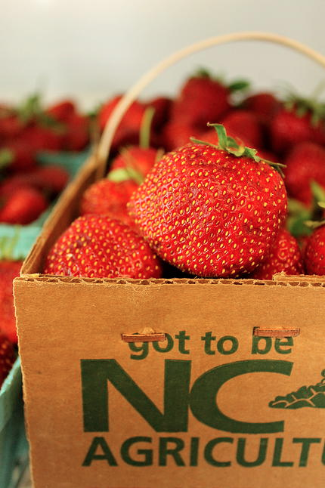

Summary of Topic:

Goal: Create a More Sustainable Menu for Winston Salem Forsyth County School District
- Decrease Carbon Footprint
- Save $$
- Have more Community Pride
What: Strawberries
When: One day of strawberries on the menu in May
Who: Will use “Farm to School” North Carolina Farm – North Carolina Strawberry Association http://www.ncstrawberry.com/

Definitions:
- A “carbon footprint” is defined as the total sets of greenhouse gas emissions by an organization, event, product or person.
- “Food Miles” or “Food Kilometres” is a measure of the distance that food travels from the farm to your plate.

Food items that have been imported typically travel long distances, using large amounts of fossil fuels, which creates a large amount of greenhouse gas emissions. Forsyth Country’s goal is to create a more sustainable menu by purchasing strawberries that are grown closer to our location vs from California. We want to cut down on thousands of food kilometres and help the environment. We want to support the local economy, contribute to the wider educational mission and overall have more community pride. Direct benefits will include: fresher produce, lower transportation costs and ability to purchase smaller quantities (1). We will be faced with a number of obstacles including: seasonality and overall limited availability and difficulty with the related concepts of logistics (ordering, delivery, billing) and risk management (ensuring timely delivery and adequate volumes of high-quality, safe foods that adhere to required specifications). I feel the money and CO2 saved (calculated below) outweigh the work that will be needed to get through the obstacles.
(1) Conner, David S. , Abate, Getachew , Liquori, Toni , Hamm, Michael W. and Peterson, H. Christopher(2010) 'Prospects for More Healthful, Local, and Sustainably Produced Food in School Meals', Journal of Hunger & Environmental Nutrition, 2010; 5(4):416-433.

North Carolina is ranked third in the U.S. in strawberry production. The following are USDA figures regarding NC’s strawberry production:
Acreage in production: approximately 1600 (2012, USDA figures)
Total annual production: approximately 20.3 million pounds (2012, USDA figures)
Value of annual strawberry crop: $29.4 million farm income (2012, USDA figures)
(North Carolina Strawberry Association. Strawberry Association Web Site “About North Carolina’s Strawberry Industry” http://www.ncstrawberry.com/docs/StrawberryIndustry.htm. Published 2013. Updated January 2015. Accessed March 23, 2015)

Costs and Measurements:

Foster-Caviness vs. (Farm-to-School) Patterson Farm Inc

Vendor | Quantity of strawberries | Cost per case | Cost for 500 cases | Distance from WS | Carbon Footprint
Foster-Caviness in California* | 8 lbs cases x 500 cases = 4,000 lbs | $24.85 | 500 x $24.85 = $12,425 | 2,610 miles | 2061.6 kg of CO₂ emitted into the atmosphere*
Patterson Farm Inc in North Carolina | 8 lbs cases x 500 cases = 4,000 lbs | $13.75 | 500 x $13.75 = $6,875 | 49.9 miles | 39.3 kg of CO₂ emitted into the atmosphere*
*Caron Footprint calculated with The Food Miles Calculator at The Food Miles Calculator Web Site http://www.fallsbrookcentre.ca/cgi-bin/calculate.pl. Published 2006. Updated August 2014. Accessed March 23, 2015)
* Foster-Caviness Foodservice Master Price List, Effective: 03/09/2015. Page 3

That’s a difference of $5,550 dollars, 2,560 miles and 2,022.3 kg of CO₂ !!!

Interesting fact: 1 kg of CO2 = Production of 1/3 of an American cheeseburger or each cheeseburger emits 3.1 kg of CO2. That's a difference of production of 652 cheeseburgers worth of CO2!!!

Email received from Doug Patterson of Patterson Farm Inc.
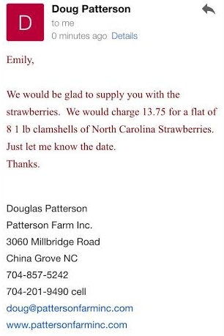
Doug confirmed that he could supply Winston Salem Forsyth County schools with 500 8 lbs cases of strawberries for the one day in May. He would charge $13.75 per case, and can deliver to our location. Doug can be emailed at doug@pattersonfarminc.com .

Distance from Winston Salem Child Nutrition Office to Patterson Farm
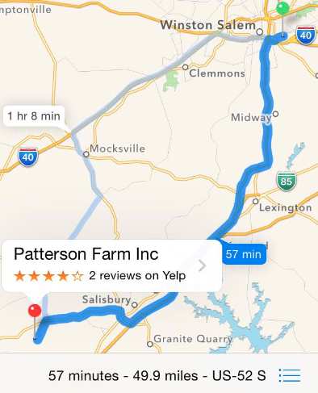

I also contacted the North Carolina Strawberry Association via email asking them, which Farm-to-School farms are located close to Winston Salem can provide the amount of strawberries we need. I received this answer from Kristy Phillips (executive secretary) info@ncstrawberry.com

Good morning Emily,
We appreciate you contacting us regarding this great opportunity for our growers to partner with Forsyth County Schools! I wanted to let you know that I have asked our Executive Committee for suggestions as how best to proceed. I have also reached out to several farms in your area so I will get back with you as soon as possible.
Thanks,
Kristy

That afternoon she responded again saying:

Good afternoon Emily,
I’ve spoken to one farm and they have a few questions……
1. Do you know what date in May you would like to get the strawberries?
2. How would you like the strawberries packaged? You mentioned 8lb cases, correct?
3. Will someone be able to pick them and distribute to each school?
4. Do you have a budget?
Mother’s Day weekend (May 10th) is very busy so it will probably work better if you could use the strawberries the following week (May 18th).
Thanks,
Kristy

Start up:
If Winston Salem Forsyth County decides to move forward with this project, it would be a good idea to contact Patterson Farm Inc or Kristy Phillips to talk details. The RD has their contact information.
- Follow the procurement process of food items
- Set up chosen farm as a vender
- Set up chosen farm in Charwells account
- Make sure to show quotes for separate biding
- Prior to serving – The Child Nutrition team can promote their sustainable menu utilizing marketing techniques in order to get the students excited about the environment and strawberries
Let’s say the fresh strawberries are on the menu for a Thursday:
- Monday - Have Patterson Farms (or other chosen farm) deliver strawberries to Child Nutrition Office at 2233 Marble St to be held at safe temperature in the large holding refrigerator in the basement.
- Tuesday and Wednesday - Have strawberries delivered to various schools via food truck. The strawberries can be delivered with the daily deliveries of bread from the office. Each school will hold the strawberries at a safe temperature in their holding refrigerator.
- Thursday – Properly wash and serve the fresh strawberries to the students.

The projects process and outcomes can be measured by:

- The final cost of the fresh strawberries and delivery
- If the students took the fresh strawberries during lunch
- If the students consumed the strawberries during lunch
- Feedback from the students using an evaluation form (strawberry report card )
- If working with the Farm-to-School farm was a pleasurable experience (feedback from all parties involved using an evaluation form that can be filled out online)

